**RELEASING UNASSEMBLED SETS & Automatically Create Component Releases**

N-K-1 OEShip parameter with Logical Value = YES.  
This will list the Unassembled Set and all the Components of the Set on the Items Tab of the order.   
Only the parts of the set can be released and shipped. Therefore, the release must be created for each part. Obviously, this can be time consumming when Sets may have up to 99 parts.

Now, One Button can create 99 Releases in one Step. Highlight the Set item. Click the Release Tab.  
Click the ADD button and a popup window will appear to release all components at once.

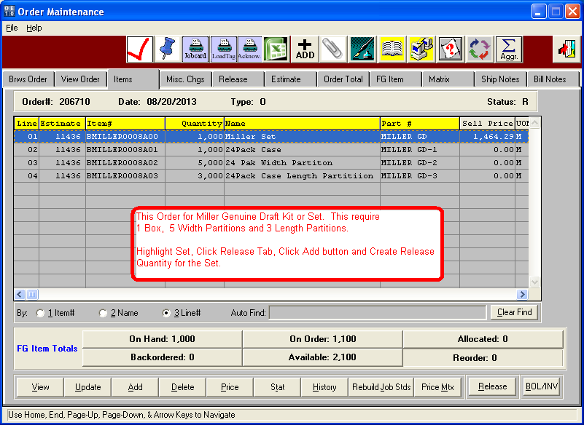

**RELEASING UNASSEMBLED SETS & Automatically Create Component Releases**

ADD Button on Release Tab will prompt for Ship To Location, Set quantity to release and to Add new Release or to Replace an existing Release Date. This will multiple the Set Release Quantity by the Qty/Set of each component to create the release quantity for each component.

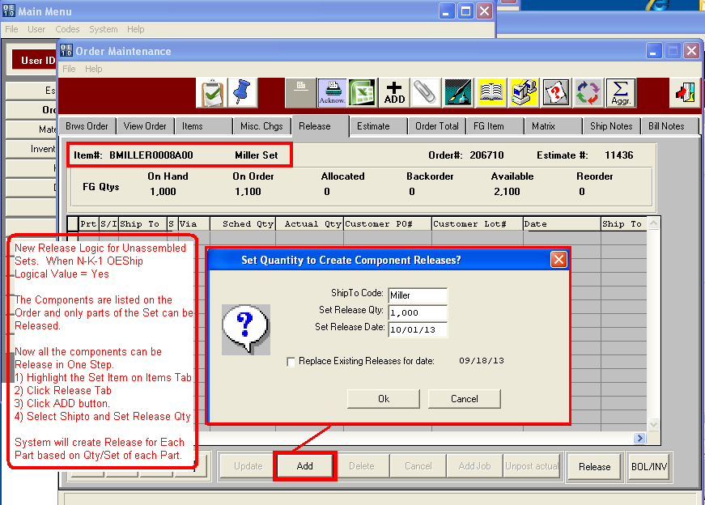

**RELEASING UNASSEMBLED SETS & Automatically Create Component Releases**

A separate Release is Created for Each Component based on the Qty per Set.

